**Lesson 14**

**HAL. USART. Receiving data**

In the [**last lesson,**](http://narodstream.ru/stm-urok-13-hal-usart-peredacha-dannyx/) we figured out the technology of data transfer using the USART interface, tried it in practice.

First, you need to handle the interruption from USART, you do not guess when to take us.

Secondly, somewhere and somehow this should be displayed.

This is where our good old display 20x4 comes to our aid.

We connect it on the same 4-bit scheme (click on the image to enlarge the image)

[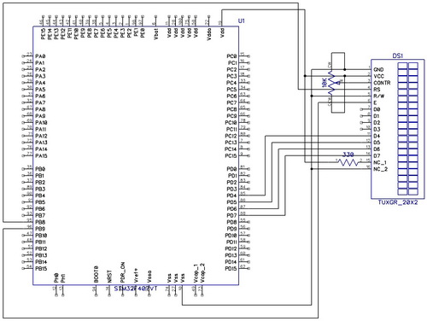](http://narodstream.ru/wp-content/uploads/2016/12/Image00-1.jpg)

In this regard, we will create a new project USART_RECEIVE from another project - MYLCD80

We start the newly created project in CUBE, we include the same way USART2 - Asynchronous.

Same settings. as well as in the project with data transfer should be in Configuration.

The only difference is that in USART in Configuration on USART2 we enable interrupts

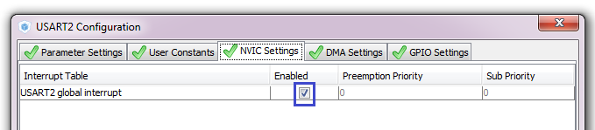

We generate the project. We open it.

Add the file lcd.c.

We collect, we sew, we look, to be convinced, that the display at us works.

If the display is working, then we work with the code.

On the display, we leave only this in the code

/ * USER CODE BEGIN 2 * /

**LCD_ini ();**

**sprintf (str, "Stm32F407VG");**

**LCD_String (str);**

**LCD_SetPos (10, 2);**

**sprintf (str, "ARM mc");**

**LCD_String (str);**

  / * USER CODE END 2 * /

The rest is removed, we also remove everything from the infinite loop, and remove the variable i.

Let's add the code to main ()

  / * USER CODE BEGIN WHILE * /

**str [8] = 0;**

**HAL_UART_Receive_IT (& huart2, (uint8_t *) str, 8);**

  while (1)

  {

**HAL_Delay (100);**

**if (huart2.RxXferCount == 0)**

**{**

**LCD_SetPos (0, 3);**

**LCD_String (str);**

**str [8] = 0;**

**HAL_UART_Receive_IT (& huart2, (uint8_t *) str, 8);**

**}**

  / * USER CODE END WHILE * /

We collect, sew, look.

From the terminal program we try to enter characters (necessarily exactly 8, well, or in another way, but until 8 is typed, nothing will be displayed on the display)

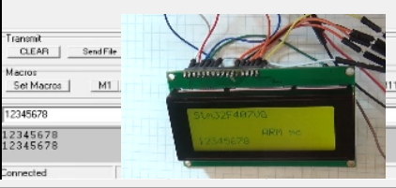

In future projects, we will definitely return to the USART data reception mode using interrupts, although not very soon, but we will return.